Under embargo till December 7, 11.30 CET
Communication memo COP24 side-event from Holland Circular Hotspot, Zero Waste Scotland, Sitra, Circular Norway, Poland Circular Hotspot and Luxembourg Circular Hotspot.

Circular Economy: the missing link in the Climate discussion
There is growing awareness that the Circular Economy is a missing link in the Paris agenda and that it is urgent to strengthen the link between Circular Economy and the Climate Change Agenda. A circular economy aims to decouple economic growth from the use of natural resources and ecosystems by using those resources more effectively. During the COP24 climate summit in Katowice in December 2018, a coalition of European circular hotspots presented evidence and best practices of the circular economy as a means to bridge the gap in the climate agenda and identified where there is potential for scaling up.
They brought along forward looking members from the business and science communities and, supported by facts & figures and showcases by best practices, pointed at the significant contribution the transition to a circular economy has towards reaching the climate goals.
The Circular Economy not only contributes towards CO₂ reduction it is also keeps materials in the loop and is restorative in nature. The greenhouse gas emission (GHG) reduction potential is not cost driven but based on sound and inspiring business models that have significant potential in every market segment and can work both in developed and developing nations. A transition that can start small but has a tremendous potential to scale up. The organisers aim at sending a strong signal to the formal COP representatives about the importance of adopting circular economy strategies that can start today.
Kari Herlevi, Project Director, Circular economy at Sitra: “making better use of the materials that already exist in the economy, using circular business models and having greater material efficiency can take EU industry halfway towards net-zero emissions in an economically attractive way”

A large part of CO₂ emissions that the world agreed to reduce in the Paris Agreement is associated with producing materials. Sitra presented their recent study “The Circular Economy a Powerful Force for Climate Mitigation” made in collaboration with European Climate Foundation and Material Economics where they looked if we can make better use of the materials already produced, and so reduce the need for new production. The conclusion: demand-side measures can take us more than halfway to net-zero emissions from EU industry and hold as much promise as those on the supply side.
The concept of the ‘circular economy’ creates these opportunities through strategies such as recirculating a larger share of materials, reducing waste in production, replacing heavy products and structures with low weight alternatives, extending the life-times of products, and deploying new business models based around sharing of cars, buildings, and more.

Eva Gladek, CEO Metabolic: “it is essential for us to manage materials in a circular fashion in order to ensure that we have enough for the technologies critical to a low-carbon future.”

That resources are the missing link in the Climate Debate also came forward out of new research from Metabolic and Copper8 - Metal demand for Renewable Electricity Generation in the Netherlands - that identified challenges in supplying the rare earth metals needed to build enough solar panels and wind turbines to meet Paris Climate agreement targets. The report found Paris agreement goals require the global production of some metals to grow at least 12-fold towards 2050. This highlight yet another way the circular economy is an integral part of the broader sustainability transition.

National Governments signed the Paris Climate Agreement in 2015. They can set targets, support frontrunners and create financial and legal incentives. National governments are wise to integrate the Circular Economy in the implementation of the Paris agreement. Countries like the Netherlands set directions and boundaries. The Netherlands wants to be fully circular in 2050 and halve the non-renewable resource use by 2030.
Whatever ambition a national government sets, in the end it is up to business to introduce innovations and actions to scale-up.

Harald Tepper: Program Lead Circular Economy at Philips:
“Philips has embedded circular-economy thinking in its strategic vision and mission, and set ambitious target for the company. Philips aims to deliver 15% of total revenues from circular products and services by 2020. Furthermore, the company has pledged that it will take back and repurpose all the large medical systems that its customers are prepared to return to it by 2020, and that it will extend these practices to all professional equipment by 2025.”

Philips strives to make the world healthier and more sustainable through meaningful innovation. As a leading health technology company, the journey to a circular economy is core to that vision, as is the ambition to become CO2-neutral in its operations by 2020. In 2017, the company published its first, externally audited, Environmental Profit & Loss account (EP&L), as part of the Annual Report. The EP&L shows a substantial contribution from materials and components across the supply chain, thus further emphasizing the importance of a transition to the circular economy.
Philips has fully embraced circular economy principles, because of its benefits for society, and because of a strong believe that it is a driver for innovation and economic growth. That’s why it is actively working with other front-running companies, governments, and NGOs to advance the circular economy globally in the Platform for Accelerating the Circular Economy (PACE).

Jakub Wójcik, Vice-Chairman of Izodom Company: “Constructing a new building, is similar to sending a letter into the future. Traditional buildings are like sending a gift, with a growing bill to pay, an energy bill. Our children will be forced to supply them with their limited energy resources, as well as, they need to deal with the remains of our "gift". We work to make this bill smallest possible and the burden with construction waste avoidable.

The importance of the built environment sector for achieving circular economy is huge. It is the sector with the largest materials flows in the economy. Buildings and infrastructure have a very long lifetime and they are a dominant part of the footprint of a city. Today’s focus is predominantly on supply of renewable energy. There is (far) less focus on minimisation of demand for energy. Energy loss related to cooling in hot countries is probably as impactful as energy loss related to heating in cold countries
Izodom focusses on an even far larger part of the lifetime footprint of a building by introducing smartly designed and effective thermal insulation building materials that have been produced locally and can even be re-used after the life-cycle of a building into a new function. Izodom managed to send 19.000 buildings into XXII century and saved roughly, between 1990 to 2018 9mln tonnes of CO_{2,} which would have been emitted if those homes were built traditionally.”

Arve Ulriksen, CEO Mo Industripark: “Most things start with a vision, and the goal is to set up your business in a way that enables you to fulfil your vision. It’s when we dare to say them out loud that the real work begins, and the pressure is on to fulfil them. That is what we are doing at Mo Industripark. More sectors need to step it up and vocalize a vision when it comes to mitigations climate change through circular economy. We need to be bold and think big if individual small contributions are to make up a cohesive whole.”

An industrial symbiosis constitutes a local partnership where, partners provide, share and reuse resources to create shared value. The purpose of industrial symbiosis is to create loops of technical or biological materials while minimising the leakage and waste in the loops - demonstrating some key parts of a circular economy, at a local scale.
Mo Industrial Park is the largest industrial cluster in Arctic Norway. 108 different companies within process industry, marine sector, mining, datacentres, service sector and many more, enjoy an advanced industrial symbiosis. Some overarching achievements include the recovery of heat from the industry equivalent to the annual energy consumption of the city of 24 000 inhabitants. This recycled energy is used to produce smolt within the park and district heating in the city of Mo i Rana, ensuring ice free streets and heated sports arenas, hospital and other public buildings.
Also, when it comes to by-products from the process industry, Mo Industripark utilize dust, slag, CO-gas and refractory materials over and over, making sure they stay in a circular loop.

Callum Blackburn, Head of Policy, Research and Evaluation at Zero Waste Scotland:
“The circular economy isn't just about tackling climate change - it will also be a boost to local economies. We have identified a wide range of exciting business opportunities in the emerging circular economy, which could be worth £1bn to the economy of two of Scotland’s regions alone.”

In cities everything comes together. Cities are the place of action. With large populations and an abundance of resources in a small geographic area, cities offer an ideal location for new circular economy business models. The volume of businesses and people also give sufficient scale to enable the change. A key strand of Zero Waste Scotland’s circular economy strategy is to take a cities and regions approach, as it allows for a cross-sectoral focus, taking advantage of the benefits and potential synergies between businesses from different sectors.

Recent reports focussing on Scottish cities and regions from Zero Waste Scotland have demonstrated the scale of potential opportunities. Going forward we must align public, private and academic sectors to fully exploit the opportunities that the circular economy offers.

Conclusions and recommendations

The side event at the COP24 presented many examples and gave evidence of the potential of a Circular Economy transition.
There are much more Circular Economy cases than the ones presented today. We could have also mentioned that globally, about one third of all food produced is lost or wasted along the management chain, contributing to greenhouse gas emissions and other environmental issues, wasting tremendous resources in the production processes, and making recyclable materials in the waste stream harder to recover. Managing food waste sustainably could reduce greenhouse gas emissions by up to 518 million tonnes, which is the equivalent of taking all the cars off the road in the European Union (WBA, C40 2018). Again, the potential is valid for developed and developing countries.

In all, Circular Economy is the way forward to decouple economic growth from the use of natural resources. It contributes significantly to the Climate Goals not as a cost factor but by viable business models. A Circular Economy transition can start small but has a tremendous potential to scale up. Unleashing the potential requires eliminating Circular Economy barriers and stimulating drivers to make the transition happen.
Recommendations that come forward when considering the many circular economy cases that are operational today.

Integrate Circular Economy and Climate Policies
- Many governments have adopted legislation to improve waste management—just one aspect of circular economy and often not tied to climate policy—but few have adopted legislation that tries to reduce waste holistically and at the source or in conjunction with climate action. Circular economy policies targeted to the source of waste include lifetime extension, modular design, design for disassembly, material and resource passports, and international cooperation on supply chains.
- As industry associations and the European Commission consider new mid-century ‘roadmaps’ for industry, they should include circular economy measures for cost-effective ways to achieve deep emissions cuts.

Policy Levers for a circular economy and climate measures can work in tandem
Some policies have been identified as effective.
- More emphasis on Design.
In the design phase probably 80% of the environmental footprint can be determined.
- Incentives for green public and private procurement help create demand for circular products. Public procurement is 20% of EU GDP and can create a huge pull factor for new circular innovations.
- Extended producer responsibility schemes introduce life-cycle thinking in manufacturing, in supporting the marketing of better products, and in promoting responsible interaction between producers and consumers. When set up in close alignment between government, producers and taking consumers into account they have proven to be effective in the European Union and in front- running countries such as France.
- Supportive tax reform can make it more attractive for companies to adopt circular business models, even if these are more labour intensive.
- Use metabolic approaches to identify mitigation options.
Capacity building should step away from a focus on the sources of emissions to developing an understanding of how resources, both raw materials and fuels, are used to deliver services to society. This requires a metabolic analysis, a mapping of the flows and stocks of materials and energy, aiming for improvement of the system and the way it responds to societal needs.
- Aligning standards and definitions across borders, for example regarding a waste and a resource status

Cities as the place of action
- Where-as national governments set the ambition and create the boundaries and companies have to do the major part of the scaling-up the place where circular action can start and grow is often in cities. Local governments should bring stakeholders together, share best practices, show the potential and give the example

System change
Circular Economy is a new way of designing, producing, consuming and dealing with waste. It about innovation (like the tremendous opportunities of digitisation) and new cross sectoral collaboration.
The greenhouse gas emission (GHG) reduction potential of circular economy is not cost driven but based on sound and inspiring business models that have significant potential in every market segment and can work both in developed and developing nations. A Circular Economy is also an opportunity to create jobs and raise standards of living. It requires that we continue to raise awareness and educate the leaders for tomorrow.

About the Initiative Takers of the COP24-Side event
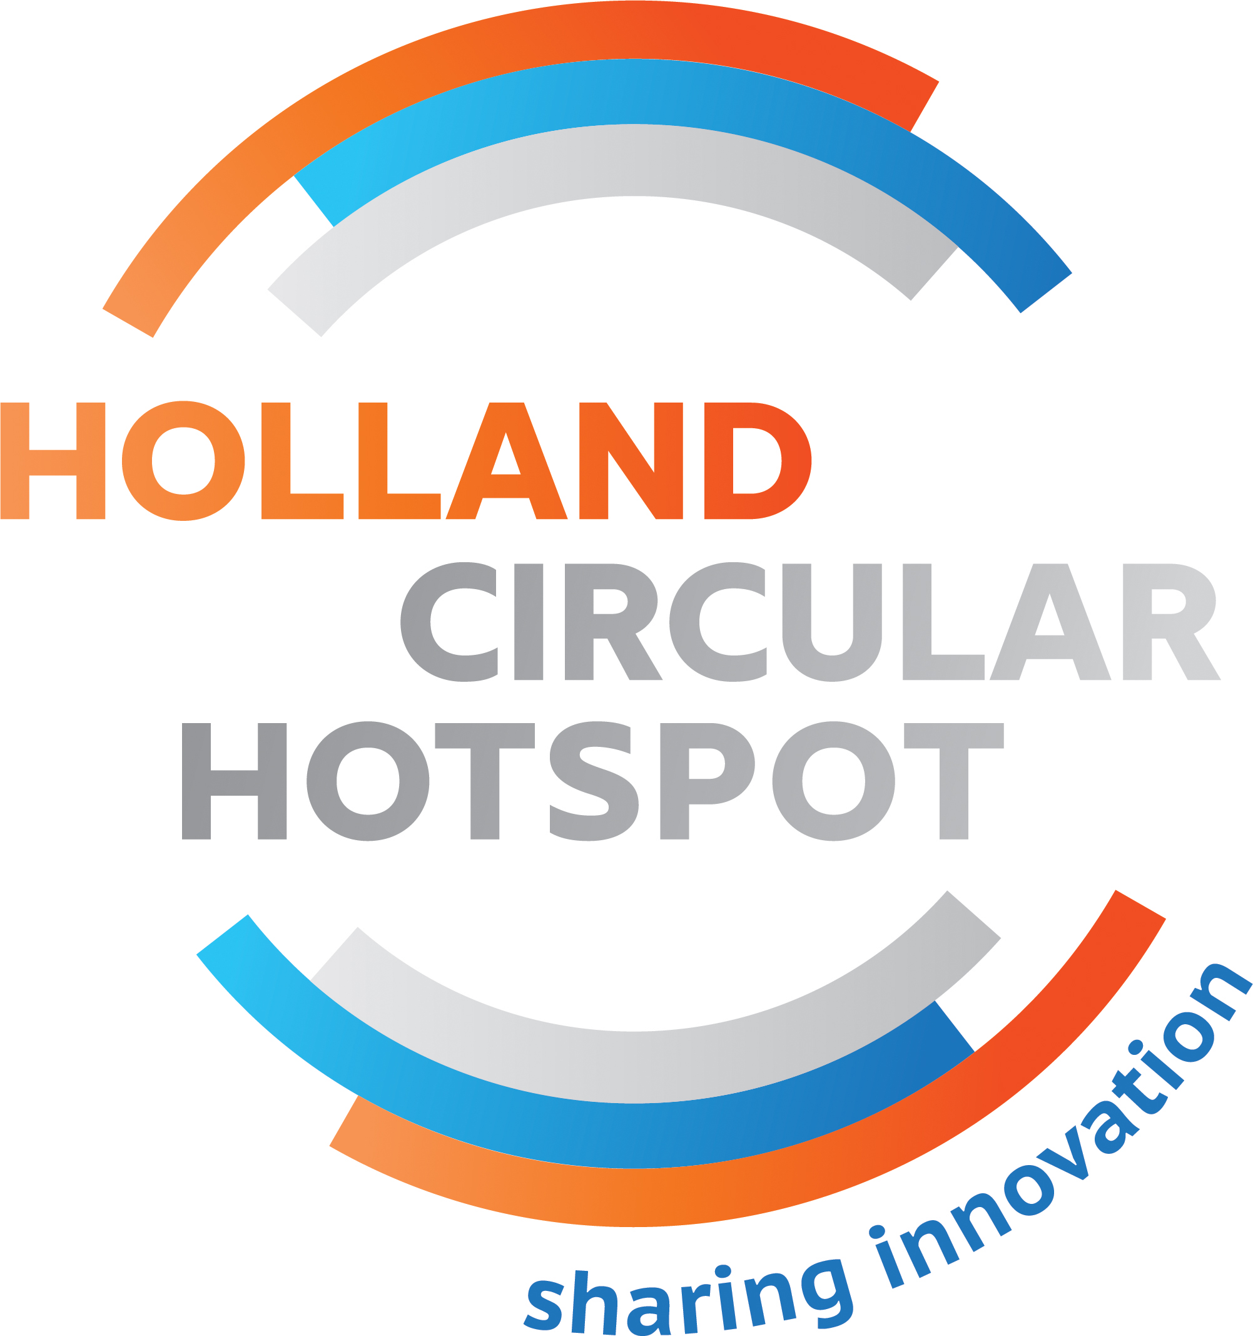
Holland Circular Hotspot
The Holland Circular Hotspot (HCH) Foundation aims to create and strengthen Circular Economy (CE) export and investment opportunities for the Dutch business community and stimulate international exchange of CE knowledge and innovation. This is done in close collaboration with the national government and the Netherlands Enterprise Agency (RVO). By doing so, Dutch knowledge and expertise will contribute to the implementation of circular economy in an international context and help to accelerate the realisation of the UN Sustainable Development Goals.
HCH activities are:
- strengthen the international cooperation between companies, knowledge institutions and governments and invites parties with a similar ambition to work closely together;
- increase the international visibility of Dutch knowledge and best practices in the field of Circular Economy
- help to make the existing instruments for trade and innovation more accessible to circular frontrunners
- act as the CE entry point for foreign parties.

Contact: Freek van Eijk, Director Holland Circular Hotspot freek.vaneijk@hollandcircularhostpot.nl
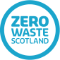

Zero Waste Scotland
Zero Waste Scotland exists to create a society where resources are valued and nothing is wasted. The goal is to help Scotland realise the economic, environmental and social benefits of making best use of the world's limited natural resources. Zero Waste Scotland is funded to support delivery of the Scottish Government's circular economy strategy and the EU Action Plan for the Circular Economy. The organisation leads on the delivery of Scottish Government's Circular Economy strategy and other low carbon policy priorities and is at the forefront of efforts to create a resource efficient, circular economy in Scotland.
Zero Waste Scotland led the delivery of Circular Economy Hotspot Scotland in October 2018, building on the success of inaugural events in the Netherlands and Luxembourg. The Hotspot was supported by funding from both the Scottish Government and the European Regional Development Fund through the Resource Efficient Circular Economy Accelerator Programme.
Contact: Callum Blackburn, Head of Policy and Research, Zero Waste Scotland
callum.blackburn@zerowastescotland.org.uk
Circular Norway
Circular Norway was established in the summer of 2017 as an initiative by actors in the electronic waste and recycling industry. However, Circular Norway is independent of sector and industry. The goal of Circular Norway is to create sustainable growth and jobs through innovation, knowledge sharing and policy impact. Circular Norway strongly believes that innovation and business development opens up through circular economy and especially by way of optimization of the value chain, creating new value streams and reducing virgin material use. Circular Norway has three main goals;
- Accelerate the transition from a linear to a circular economy
- Optimize interaction throughout the value chain
- Facilitate innovation and business development that creates new value chains that reduce resource usage so that we stay within the planetary boundaries.
In order to fulfil these goals, Circular Norway create market opportunities and innovation programs for industry through policy influence and by bringing experts together. Even though our main focus is on Norway, we believe that cooperation is the main component for the circular economy and we have therefore several partnerships outside of Norway.

Contact: Sofie Pindsle, Coordinator, Circular Norway
sp@circularnorway.no

Sitra
Sitra is a gift from Parliament to the 50-year-old Finland. It is an independent foresight agency: futurologist, researcher, visionary, developer, experimentalist, partner, trainer and networker. Sitra is funded by returns on endowment capital and capital investments.
It envisages Finland as a successful pioneer in sustainable well-being. Its vision is supported by three themes, six focus areas and dozens of projects.

Contact: Kari Herlevi, Project Director, Circular Economy at Sitra
Kari.Herlevi@sitra.fi

Polish Circular Hotspot
Polish Circular Hotspot is a public cooperation platform. Together with our partners, we work on introducing innovative, comprehensive, practical and scalable solutions in all sectors of the economy. We work with business big and small, local and nationwide governments, universities and scientists with a wide range of disciplines. We cooperate with various industries, including construction, food, packaging, electronics, plastics, logistics, transport, energy and textiles.
Achieving far-reaching circular goals through the implementation of complex projects is made possible through cooperation and the exchange of resources, knowledge and experience. Below, we present our activities aimed at stimulating peace and seeking innovative solutions.

Contact: Agnieszka Sznyk, President of INNOWO, Polish Circular Hotspot coordinator
a.sznyk@innowo.org

Luxembourg Circular Economy Hotspot
Luxembourg Circular Economy Hotspot is the name of an event organized in Luxembourg in 2017. The new government is in place since December 5th, 2018 and its 5 year programme is a clear commitment to the circular economy which is highlighted all throughout the document. The Luxembourg Ministry of the Economy and the Ministry of Energy and Land Use Planning share the responsibility for its implementation.

Contacts: Paul Rasqué, Attaché de Gouvernement 1eren rang and Christian Tock, Attaché, Director Sustainable Technologies
christian.tock@eco.etat.lu and paul.rasque@mev.etat.lu

The COP 24 event is initiated by the Dutch Holland Circular Hotspot foundation and organized together with Zero Waste Scotland, Sitra, Circular Norway, Poland Circular Hotspot and Luxemburg Circular Hotspot.

